HOW TO GUIDE FOR TAKING YOUTH PROTECTION TRAINING
(Recommended Browsers are Google Chrome for the PC or Safari for the MAC).
1. Go to http://my.scouting.org
2. Enter your login name and password, OR click on CREATE AN ACCOUT on the Left Side
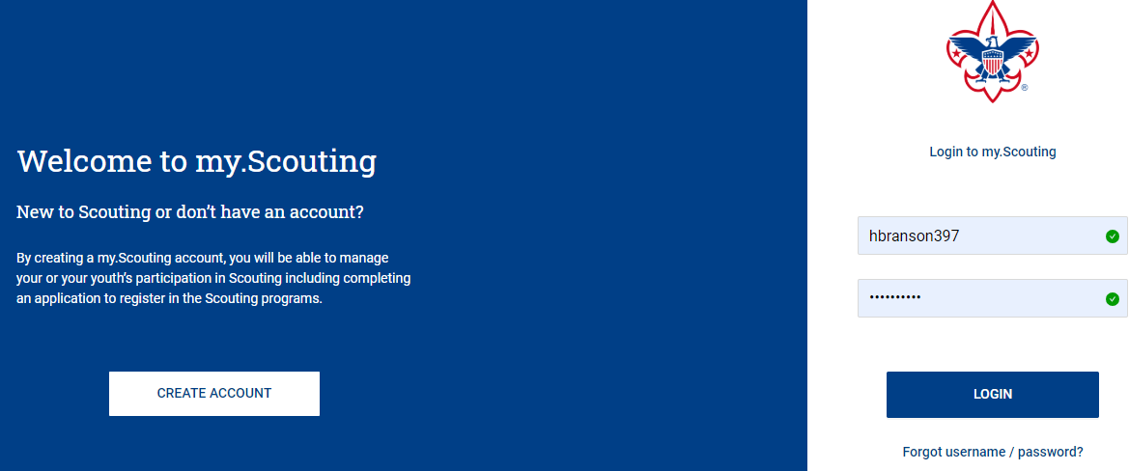
3. On the opening page of my.scouting.org, click on the Youth Protection logo for English or Spanish.
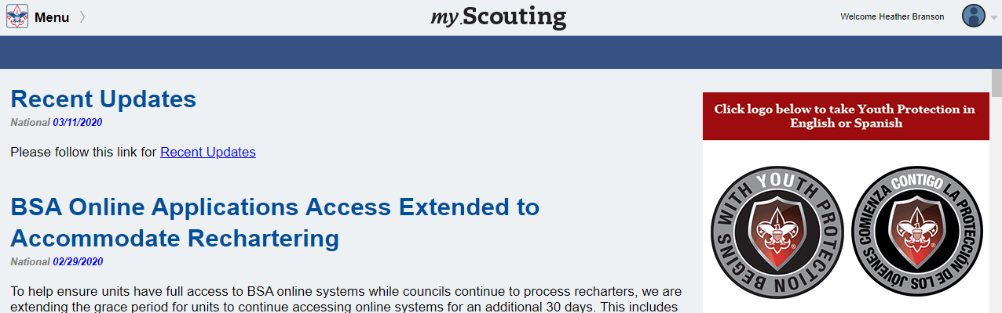

4. Scroll Down the Page and click on the +ADD Plan Button for the Youth Protection Training - MANDATORY V2
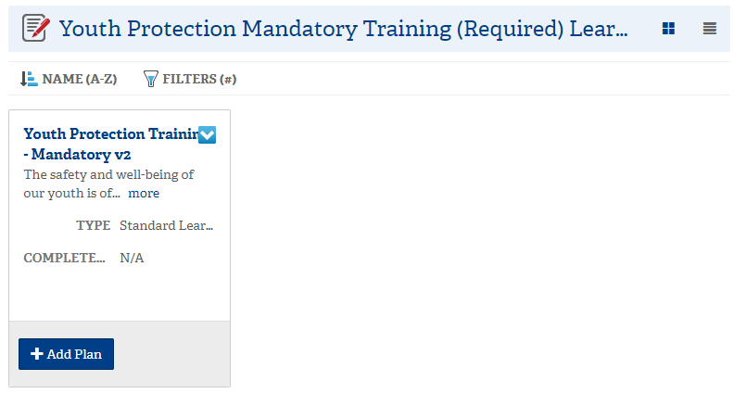
5. Once your plan has been added you will receive the notice below. Click on the title of the learning plan which opens the course listings.
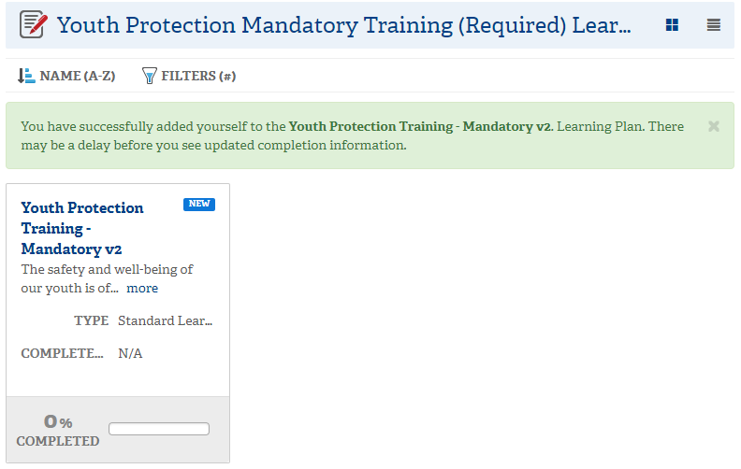
6. Select the Launch Course button to begin training for each section of the Course
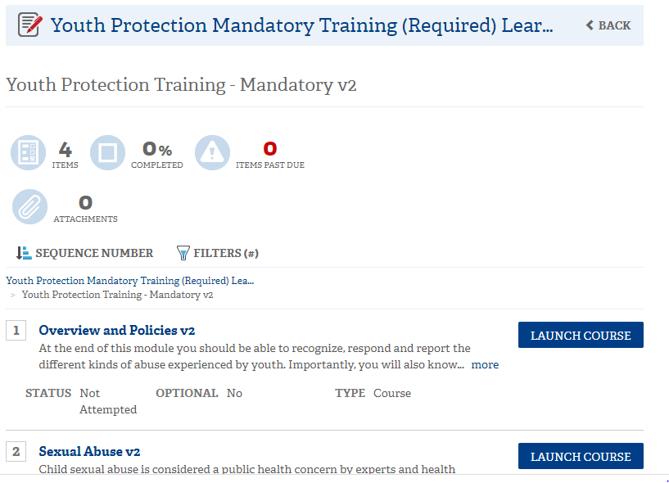
7. Click on the Button to begin the Module.
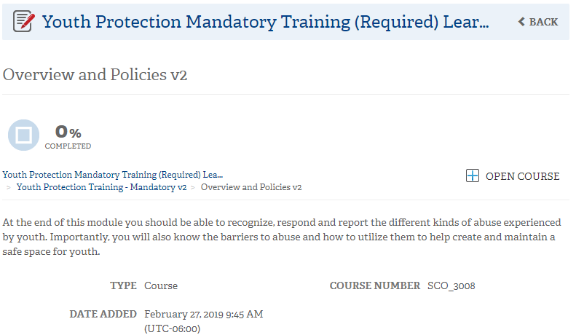
8. Select the Start button to begin the module.
Navigation tools include:
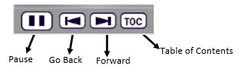
In order to meet timing for state regulations, you will not be able to fast forward (button will be grayed out) until the audio finishes playing for each slide. Once the audio is completed, the forward button will appear. Click the forward button to proceed.
9. Upon completion of each course select the button which will register complete status.
10. Select the button to go back to other course selections.
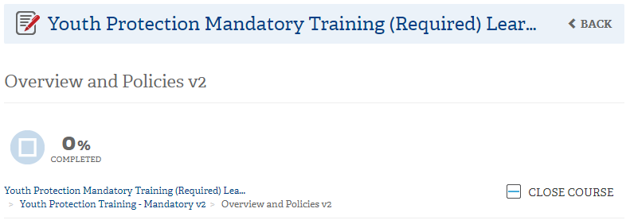

11. The Youth Protection Training consists of three modules and a test module. All 4 modules will need to be completed to be considered trained for the Youth Protection Training. Once all 4 modules have been completed you will see a YO1 completion indicator in my.Scouting.org indicator.
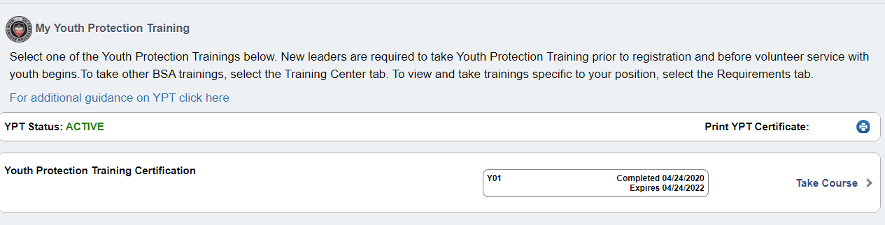
12. You may now print out a Youth Protection Training Certificate by selecting the printer icon.

Due to the large number of users who complete the course, the synchronization time from the BSA Learning Center to my.scouting.org can be up to 48 hours. There will be no record of you ending the course at my.scouting.org until you have completed all three modules and proof of certification.

To print the certificate of completion, return to my.scouting.org, select "Menu" and then "My Training." Select the printer icon in the "YPT Status" area to print the Certificate of Youth Protection Training.

13. Send in a copy of your certificate to confirm you are YPT trained. Once you have certified you will also be sent an email of your certificate. Forward this email gtccampstaff@gmail.com

