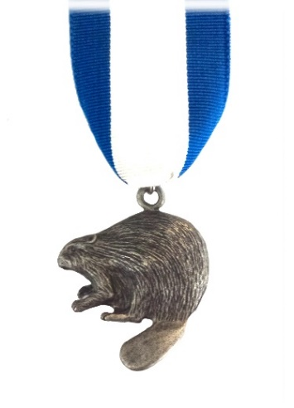

Silver Beaver

Colony #2

Grand Teton Council

April 22, 2019

Greetings Fellow Silver Beavers!

Please join us to honor great scouters at

**Council Recognition Night**

**Saturday, May 18 - at the Blackfoot Performing Arts Center,**

**870 S Fisher Ave, Blackfoot, ID 83221**

We are pleased to announce the

***New Silver Beavers for 2019***

(See the list on the back of this flyer)

At **5:00 pm** You and a guest are invited to join us for a light meal and the annual colony business meeting. – Come early to welcome the new Silver Beavers, and visit with old friends. Encourage other colony members to attend.

We will swear in the Colony officers and present the projects for the year.

The main program will commence at 6:30 pm in the auditorium, with refreshments following. Tickets to this event are not required.

If any can volunteer to help prepare and serve, or assist in clean up after the program this night, please let us know. We will meet at 4:00 pm. Call or Text Silver Beaver secretary at 208-406-1271

or e-mail sbcolony2gtc@gmail.com

Enclosed is a form for the payment of your 2019 dues, the 2019 patches, or for a donation of your choice. Your contribution is very important to the success of our colony.

The Silver Beaver Colony is able to do great things because of the funds provided by you. Some of these are:

*Recognition Night (Awards refreshments, programs, etc.)

*Newsletters to Silver Beavers; Fall Colony Gathering

*Camp Improvement Projects (Service Center maintenance projects, Island Park central dininig, fire bowl,

bear-proof containers, fencing, defibrillators, Krupp Scout Hollow upkeep, Little Lemhi -Chief Tendoy cabin, etc.)

*Chairs & tables for council conference & training meetings

*We also appreciate your support of Tiger Ears, Scouting for Food, Popcorn Sales,

and the Holiday Auction in November.

You are welcome to send in the form with your check; or bring it to the Recognition night. You can also call the service center of Grand Teton Council at 208-522-5155 to pay over the phone, or online at *www.tetonscouts.org/contribute/alumni/silver-beaver-colony/61533* ***Thank you***



The 2019 Silver Beaver Recipients

|  |  |  |
| --- | --- | --- |
| Tony | McClain | Malad |
| Michael P. | Nally | South Caribou |
| Jeralee | Neibaur | Yellowstone |
| M. Todd | Perkes | Lost River |
| Will | Ricks | Centennial |
| Darnell | Simpson | Star Valley |
| David | Sorensen | Tendoy |
| J. Meredith | Wilson | Teton |
| Kris | Wright | Eagle Rock |

|  |  |  |
| --- | --- | --- |
| Cynthia | Anderson | Blackfoot |
| William Reed | Anderson Jr. | Blackfoot |
| Jeremy | Coles | South Fork |
| Michelle | Davidson | North Caribou |
| Lyman | Dye | North Caribou |
| Gary James | Edington | Jackson |
| Patty | Hoffman | Wolverine |
| P. Briggs | Horman | North Caribou |
| Robert R. | Johnson | North Caribou |
| Benjamin | Kearsley | Teton |

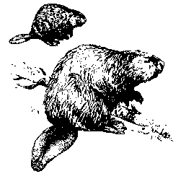

The 2019 Hall of Fame Recipient is **–**

**Stephen L. Baldwin**

As Silver Beavers, we value your continued support to the Scouting Program and events in the Grand Teton Council. Your years of service and dedication help make this Council an outstanding example of Scouting