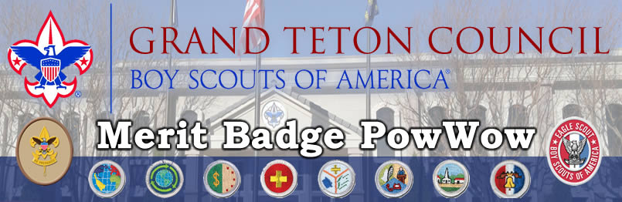

April 7 and 21st

Idaho Falls Scout Service Center

3910 S Yellowstone Hwy

Idaho Falls, ID 83402

8:00am until 12:15pm

Register at www.tetonscouts.org

You can take three Merit Badge classes

(except First Aid – lasts all morning)

$25 Registration - $30 at the Door

Registration opens February 5th

Register early – classes fill fast

**Merit Badges Offered:**

Citizenship in the Community

Citizenship in the Nation

Citizenship in the World

Communications

First Aid

Emergency Preparedness

Personal Management

Sustainability

Astronomy  
Geology

Photography  
Music

**Classes for Leaders:** Get trained for “*Introduction to Outdoor Leader Skills”* Photography beginning and advanced (bring your DSLR) and more

For Information:

[www.tetonscouts.org](http://www.tetonscouts.org)

Steve Earl at [steve@earls.us](mailto:steve@earls.us)

208-542-2585